Q1a).

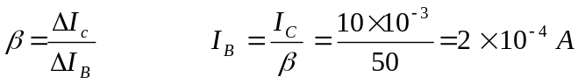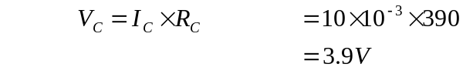
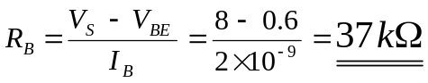

Using Kirchoff’s voltage law from the +ve rail through the collector emitter, to ground. The volt drops across the components in this closed path should result in the source voltage.

V_{s} = 8 V
V_{C} = 3.9 V

V_{CE} = V_{S} – V_{C} = 8 – 3.9 = 4.1 V

b).

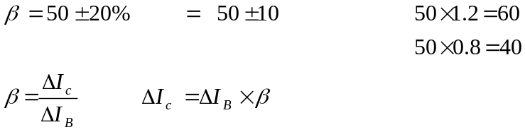

In the circuit shown an increase in β results in a proportional change in the collector current.

Hence the percentage change in collector current is ± 20%

Q2 a).

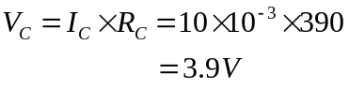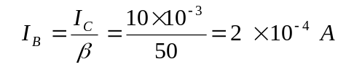

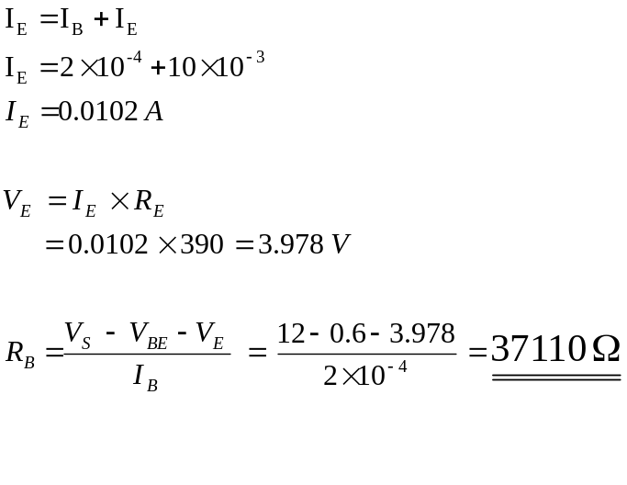Using Kirchoff’s voltage law from the +ve rail through the collector emitter, to ground. The volt drops across the components in this closed path should result in the source voltage.

V_{s} = 12 V
V_{C} = 3.9 V
V_{E} = 3.978 V

V_{CE} = V_{S} – V_{C} – V_{E} = 12 – 3.9 – 3.978 = 4.122 V

b). We need to know how I_{c} changes with respect to β.

Converting the terms with respect to I_{c} will allow its change to be seen.

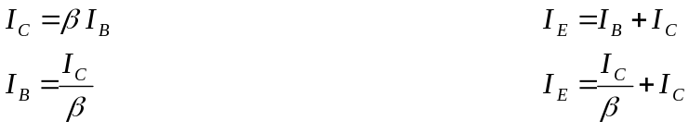
The base emitter leg of the transistor circuit will lead to the consumption of the value I_{c}. With only two unknowns in this leg of the circuit, I_{B} and I_{E}, the conversion of these unknowns into their respective of I_{c} values using Kirchoff’s voltage law, will lead to the possession of I_{c.}
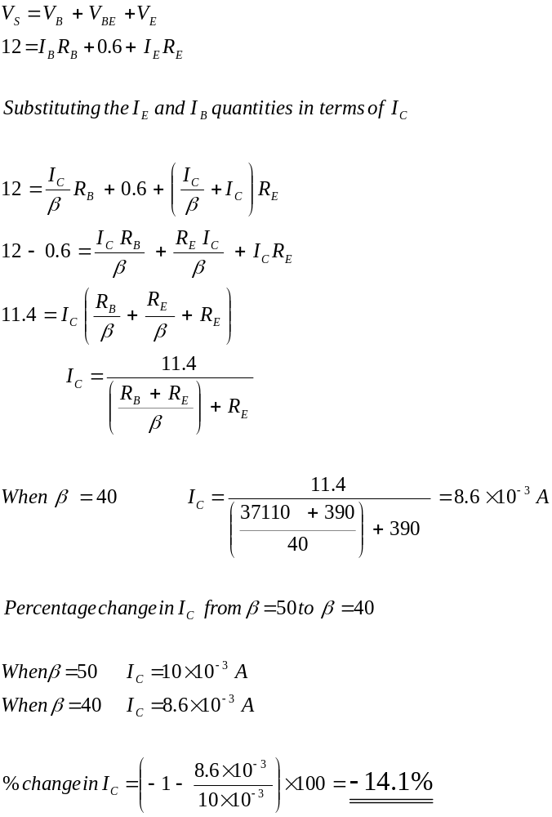

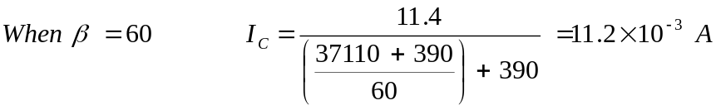
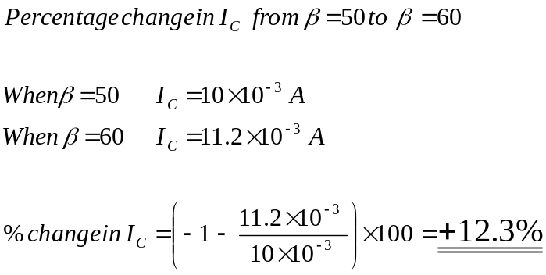
Hence the percentage change in I_{c} is +12.3, -14.1%.

The overall change in I_{c} is 12.3 + 14.1 = 26.4 % as opposed to a 40% change resultant from the first circuit.

c). In the first circuit I_{c} is directly proportional to β which means an X% rise in β will result in an X% rise in I_{c}. For the second circuit this is not true, the equation shown in the dashed line box shows a different relationship. By the addition of the emitter resistance to the denominator of the equation, which isn’t present in the first circuit equation. This increase in the value of the denominator will obviously decrease the value of I_{c}, because the emitter resistance in the denominator is irrespective of β.

